Supporting Information

**Table of Contents**

1. Supplementary Figures and Tables 2

2. Synthesis and analysis of ligands. 3

3. 1H NMR and 13C NMR of the ligands. 7

4. 1H NMR of the Polymers. 12

5. GPC Spectrum of the Polymers 18

6. DSC of Polymer. 25

7. X-ray Crystallography 31

8. References 32

# Supplementary Figures and Tables

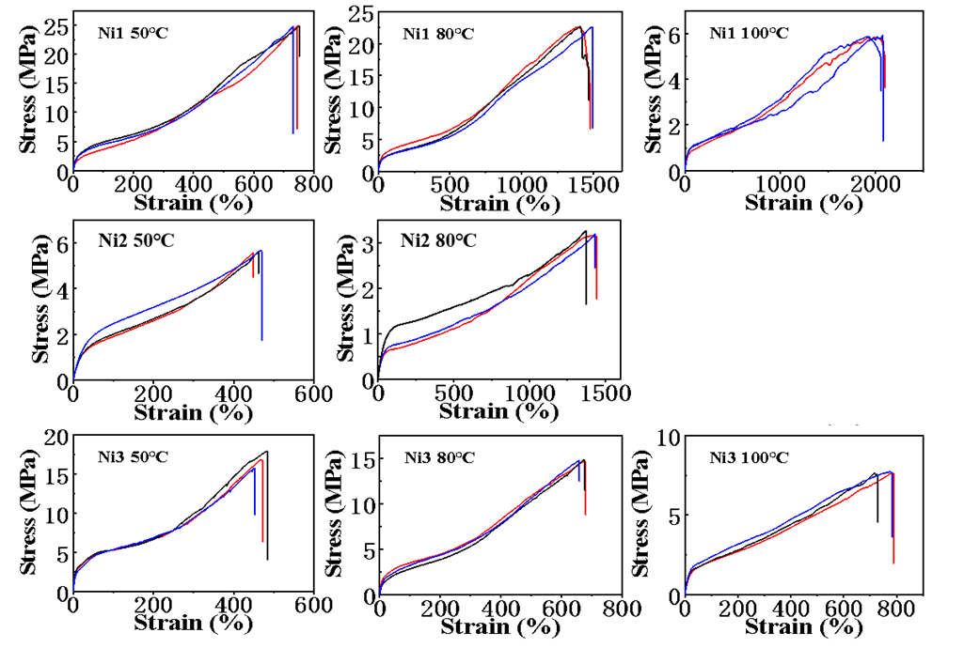

**Figure S1.** Stress and strain curves of polymers generated by catalysts **Ni1**-**Ni3**.

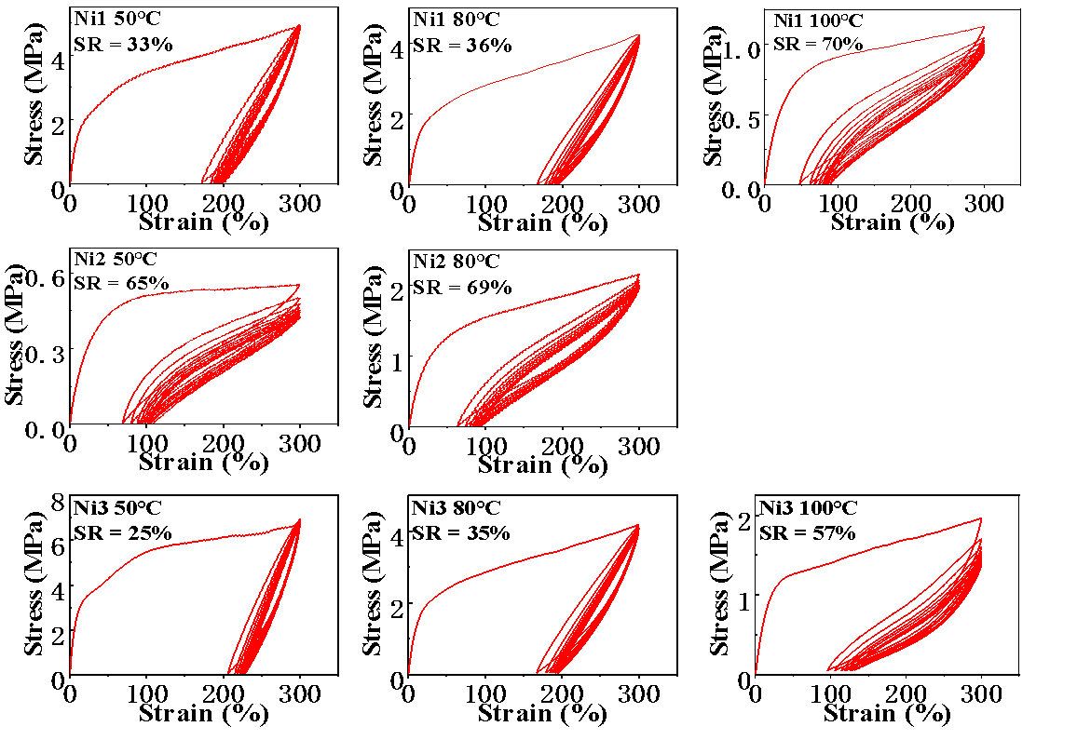

**Figure S2.** Plots of hysteresis experiments of ten cycles at a strain of 300% of polymers generated by catalysts **Ni1**-**Ni3**.

# 2. Synthesis and analysis of ligands.

All manipulations were carried out using standard Schlenk or in glovebox unless otherwise mentioned. Toluene, CH2Cl2, CDCl3 and *n*-hexane were purified over 4 Å molecular sieves. All the other reagents were used as received from commercial sources. Nuclear magnetic resonance (1H, 13C NMR) spectra were recorded on a Bruker 400 MHz instrument at room temperature unless otherwise stated. Differential scanning calorimetry (DSC) was performed by a DSC Q20 from TA Instruments. Samples were quickly heated to 150 oC and kept for 5 min to remove thermal history, then cooled to 40 oC at a rate of 10 K/min, and finally reheated to 140 oC at the same rate under a nitrogen flow (50 mL/min). The maximum points endotherm (heating scan) were taken as the melting temperature (*T*m). Molecular weight and molecular weight distribution of the polymer were determined by gel permeation chromatography (GPC) with a PL220 equipped with two Agilent PL gel Olexis columns at 150 °C using 1,2,4-trichlorobenzene as a solvent, and the calibration was made using polystyrene standard and are corrected for linear polyethylene by universal calibration using the Mark-Houwink parameters of Rudin: K = 1.75 ×10-2 cm3/g and R = 0.67 for polystyrene and K = 5.90 × 10-2 cm3/g and R = 0.69 for polyethylene. Single crystals of the metal complexes were obtained by diffusion of hexanes into THF solutions. X-ray diffraction data were collected at 298(2) K on a Bruker Smart CCD area detector with graphitemonochromated Mo Kα (λ = 0.71073 Å) radiation at room temperature. Elemental analysis was performed by the Analytical Center of the University of Science and Technology of China. Mass spectra were recorded on a P-SIMS-Gly of Bruker Daltonics Inc (EI+). HRMS spectra were measured on a GCT premier CAB048 mass spectrometer operating in MALDI-TOF (matrix-assisted laser desorption/ionizationtime-of-flight) mode.

Bis(4-methoxyphenyl)methanol1, bis(4-(tert-butyl)phenyl)methanol2 and bis(4-fluorophenyl)methanol3 were prepared according to published procedures. **Ar1-NH2**,**Ar2-NH2** and **Ar3-NH2** were synthesized according to the literature procedures.4

**Preparation of Ar1-NH2:** A mixture of 2,4-dimethyl aniline (1.21 g, 10 mmol) and bis(4-methoxyphenyl)methanol (2.44 g, 10.0 mmol) was heated to 120°C. A solution of anhydrous zinc chloride (0.68 g, 5.0 mmol) in concentrated hydrochloric acid (0.84 mL, 37% in H2O) was added to the mixture (exothermic + intense bubbling), and the temperature was raised to 160 °C. After 30 min at 160 °C, the reaction mixture was cooled to room temperature and dissolved in CH2Cl2 (100 mL). The CH2Cl2 layer was washed with water (3 × 100 mL) and dried with Na2SO4. The solution was concentrated to 10 mL. The product was crashed out with 100 mL methanol and washed with methanol (3 × 100 mL). The desired aniline was obtained as a white solid (3.00 g, 86%). 1H NMR (400 MHz, CDCl3) δ 7.13-6.90 (m, 8H), 6.86-6.79 (m, 1H), 6.28 (s, 1H), 5.46 (s, 1H), 3.34 (s, 2H), 2.14 (d, *J* = 16.0 Hz, 6H).

**Preparation of Ar2-NH2:** Similar procedure as **Ar1-NH2** was employed except bis(4-(tert-butyl)phenyl)methanol (2.96 g, 10.0 mmol) was used. The product **Ar2-NH2** was obtained as a white solid (3.50 g, 87%). 1H NMR (400 MHz, CDCl3): δ7.28 (s, 3H), 7.22 (s, 1H), 7.05 (s, 4H), 6.80 (s, 1H), 6.40 (s, 1H), 5.42 (s, 1H), 3.28 (s, 2H), 2.13 (s, 6H), 1.30 (s, 18H).

**Preparation of Ar3-NH2:** Similar procedure as **Ar1-NH2** was employed except bis(4-fluorophenyl)methanol (2.96 g, 10.0 mmol) was used. The product **Ar3-NH2** was obtained as a white solid (2.81 g, 87%). 1H NMR (400 MHz, CDCl3) δ 7.02 (d, *J* = 8.0 Hz, 4H), 6.82 (d, *J* = 8.0 Hz, 5H), 6.35 (s, 1H), 5.44 (s, 1H), 3.78 (s, 6H), 2.15 (d, *J* = 16.0 Hz, 6H).

**Preparation of L1:** A 200 mL round bottom flask was charged with acenaphthequinone (0.91 g, 5.0 mmol), anhydrous zinc chloride (0.75 g, 5.5 mmol), and glacial acetic acid (10.0 mL). After the 10 min heating bulky amine **Ar1-NH2** (3.47 g, 10.0 mmol) was added and the mixture was further refluxed for 1 h. The reaction mixture was cooled down and then the solid was separated and washed with diethyl ether. The solid was dissolved in dichloromethane and stirred vigorously with aqueous solution of potassium oxalate (1.66 g, 10 mmol) for 30 min. The aqueous phase was turned into cloudy due to the formation of zinc oxalate. The organic layer was separated, washed with three times with water and then dried with Na2SO4. Finally, the solvent was removed under vacuum and the product was further stirred into methanol. The product was separated by filtration and dried under vacuum to get **L1** as a yellow solid (3.40 g, 85%). 1H NMR (400 MHz, CDCl3) δ 7.63 (d, *J* = 8.2 Hz, 1H), 7.12 (t, *J* = 7.7 Hz, 1H), 7.00 (d, *J* = 8.0 Hz, 3H), 6.88 – 6.59 (m, 6H), 6.29 (d, *J* = 7.1 Hz, 1H), 5.78 (d, *J* = 8.1 Hz, 2H), 5.59 (s, 1H), 3.77 (s, 3H), 3.02 (s, 3H), 2.31 (d, *J* = 15.9 Hz, 6H). 13C NMR (101 MHz, CDCl3) δ 163.12 (s, -*C*=N), 157.77 (s), 156.42 (s), 146.43 (s), 136.05 (s), 134.23 (s), 133.46 (s), 132.74 (s), 130.80 (s), 130.51 (s), 129.07 (s), 129.01 (s), 127.89 (s), 127.81 (s), 127.08 (s), 124.95 (s), 122.56 (s), 113.42(s) (s), 112.61 (s), 55.29 (s, -O*C*H3), 54.46 (s, -O*C*H3), 50.94 (s,-*C*H), 21.37 (s, -*C*H3), 17.96 (s, -*C*H3). ESI-MS (m/z): calcd for C58H52N2O4: 840.3927, found: 841.40094 [M+H]+.

**Preparation of L2:** Similar procedure as **L1** was employed except **Ar2-NH2** (4.00 g, 10.0 mmol) was used. The product **L2** was obtained as a white solid (3.90 g, 88%). 1H NMR (400 MHz, CDCl3) δ 7.52 (d, *J* = 8.2 Hz, 2H), 7.28 (s, 3H), 7.12-7.00 (m, 8H), 6.86-6.75 (m, 6H), 6.34 (dd, *J* = 40.3, 7.7 Hz, 6H), 5.73 (s, 2H), 2.36 (s, 6H), 2.22 (s, 6H), 1.30 (s, 18H), 0.62 (s, 18H).13C NMR (101 MHz, CDCl3) δ 161.54 (s, -*C*=N), 147.34 (s), 146.35 (s), 145.43 (s), 139.86 (s), 137.91 (s), 132.51 (s), 131.56 (s), 128.33 (s), 128.17 (s), 128.06 (s), 127.89 (s), 127.09 (s), 126.94 (s), 125.84 (s), 123.77 (s), 123.73 (s), 122.91 (s), 121.44 (s), 50.52 (s,-*C*H), 33.29 (s, -*C*-(CH3)3), 32.40 (s, -*C*-(CH3)3), 30.36 (s, -C(*C*H3)3), 29.69 (s, -C(*C*H3)3), 20.26 (s, -*C*H3), 16.96 (s, -*C*H3). ESI-MS (m/z): calcd for C70H76N2: 944.6009, found: 945.6087 [M+H]+.

**Preparation of L3:** Similar procedure as **L1** was employed except **Ar3-NH2** (3.23 g, 10.0 mmol) was used. The product **L3** was obtained as a white solid (3.30 g, 87%). 1H NMR (400 MHz, CDCl3) δ 7.71 (d, *J* = 8.3 Hz, 2H), 7.14 (t, *J* = 7.7 Hz, 2H), 7.08 – 6.89 (m, 10H), 6.78 (dd, *J* = 8.3, 5.4 Hz, 4H), 6.62 (d, *J* = 1.8 Hz, 2H), 6.32 (d, *J* = 7.1 Hz, 2H), 6.01 (t, *J* = 8.5 Hz, 4H), 5.66 (s, 2H), 2.29 (d, *J* = 33.9 Hz, 12H). 13C NMR (101 MHz, CDCl3) δ 163.23 (s, -*C*=N), 162.64 (s), 161.47 (s), 160.21, 159.03 (s), 146.29 (s), 139.68 (s), 139.05 (s), 139.02 (s), 137.56 (s), 137.53 (s), 133.21 (s), 132.65 (s), 131.26 (s), 131.18 (s), 131.01 (s), 130.93 (s), 129.85 (s), 129.62 (s), 128.80 (s), 128.62 (s), 127.89 (s), 127.19 (s), 125.19 (s), 122.56 (s), 115.08 (s), 114.87 (s), 114.30 (s), 114.08 (s), 51.01 (s,-*C*H), 21.37 (s, -*C*H3), 17.93 (s, -*C*H3). ESI-MS (m/z): calcd for C54H40F4N2: 792.3128, found: 793.32013 [M+H]+.

**Synthesis and analysis of catalysts.** A 100 mL Schlenk flask was charged with ligand (1.0 mmol, 1 eq.) and dissolved in dry dichloromethane under nitrogen followed by the addition of (DME)NiBr2 (1.0 mmol, 1 eq.). The reaction mixture was stirred for 24 h. During the stirring the color of the solution was turned from yellow to red also with the precipitation of some solid. The solvent was evaporated under reduced pressure and the solid was further precipitated in pentane. The solid was filtered and washed with pentane to afford the catalyst in reddish to dark reddish color.

**Ni1:** Red solid, Yield: 87%,MALDI-TOF (m/z): calcd for C58H52Br2N2NiO4: 1056.1647 found: 979.46 [M-Br]+. Anal. Calcd. for C58H52Br2N2NiO4: C, 65.75; H, 4.95; N, 2.64 Found: C, 65.89; H, 5.11; N, 2.52.

**Ni2:** Red solid, Yield: 85%,MALDI-TOF (m/z): calcd for C70H76Br2N2Ni: 1160.3729 found: 1083.74 [M-Br]+. Anal. Calcd. for C70H76Br2N2Ni: C, 72.24; H, 6.58; N, 2.41 Found: C, 72.38; H, 6.49; N, 2.62.

**Ni3:** Red solid, Yield: 86%,MALDI-TOF (m/z): calcd for C54H40Br2F4N2Ni: 1008.0848 found: 931.45 [M-Br]+. Anal. Calcd. for C, 64.13; H, 3.99; N, 2.77; Found: C, 64.18; H, 3.79; N, 2.52.

**General procedure for ethylene polymerization.** A 350 mL glass thick-walled pressure vessel was charged with Et2AlCl co-catalyst, solvent and a magnetic stir bar. The pressure vessel was connected to a high-pressure line and the solution was degassed. The Ni complex in 2 mL CH2Cl2 was injected into the pressure vessel. The vessel was pressurized with ethylene to start the polymerization. The polymer was precipitated using acidic MeOH (5% HCl in MeOH) and dried in a vacuum oven to a constant weight.

Polymer branching density was determined by 1H NMR. B = 1000 × 2(ICH3)/3(ICH2+CH+ICH3). CH3 (m, 0.77 – 0.95 ppm); CH2 and CH (m, ca. 1.0 – 1.45 ppm).

**General procedure for ethylene polymerization.** A 350 mL glass thick-walled pressure vessel was charged with Et2AlCl co-catalyst, solvent, polar monomer and a magnetic stir bar. The pressure vessel was connected to a high-pressure line and the solution was degassed. The Ni complex 10 *μ*mol in 2 mL CH2Cl2 was injected into the pressure vessel. The vessel was pressurized with ethylene to start the polymerization. The polymer was precipitated using acidic MeOH (5% HCl in MeOH) and dried in a vacuum oven to a constant weight.

# 1H NMR and 13C NMR of the ligands.



**Figure S3**. 1H NMR (400 MHz) spectrum of **Ar1-NH2** in CDCl3 at 25 °C.

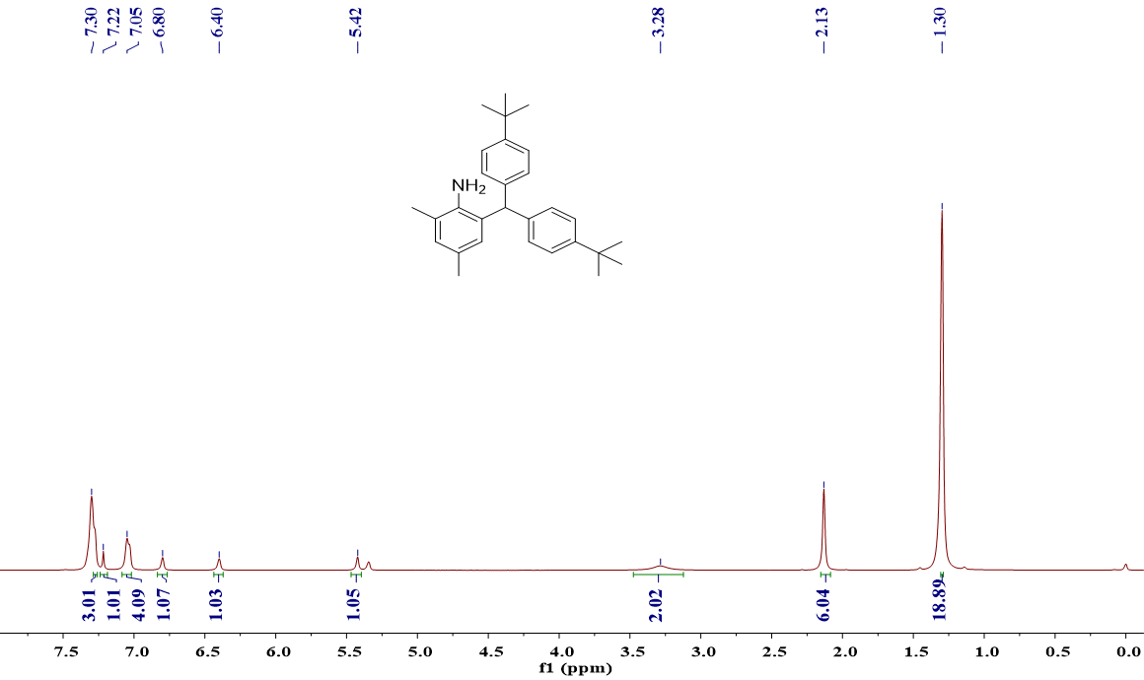

**Figure S4**. 1H NMR (400 MHz) spectrum of **Ar2-NH2** in CDCl3 at 25 °C.



**Figure S5**. 1H NMR (400 MHz) spectrum of **Ar3-NH2** inCDCl3 at 25 °C.



**Figure S6**. 1H NMR (400 MHz) spectrum of **L1** in CDCl3 at 25 °C.

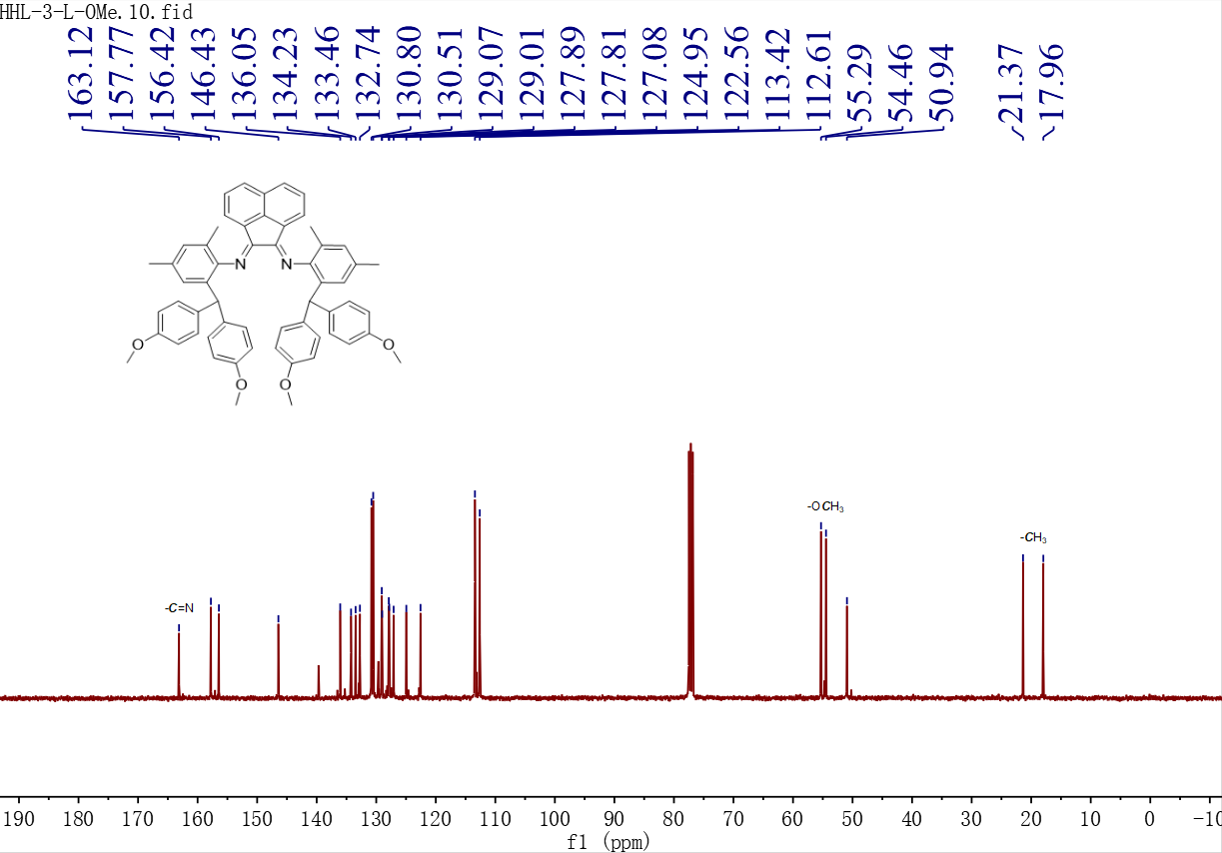

**Figure S7**. 13C NMR (101 MHz) spectrum of **L1** in CDCl3 at 25 °C.



**Figure S8**. 1H NMR (400 MHz) spectrum of **L2** inCDCl3 at 25 °C.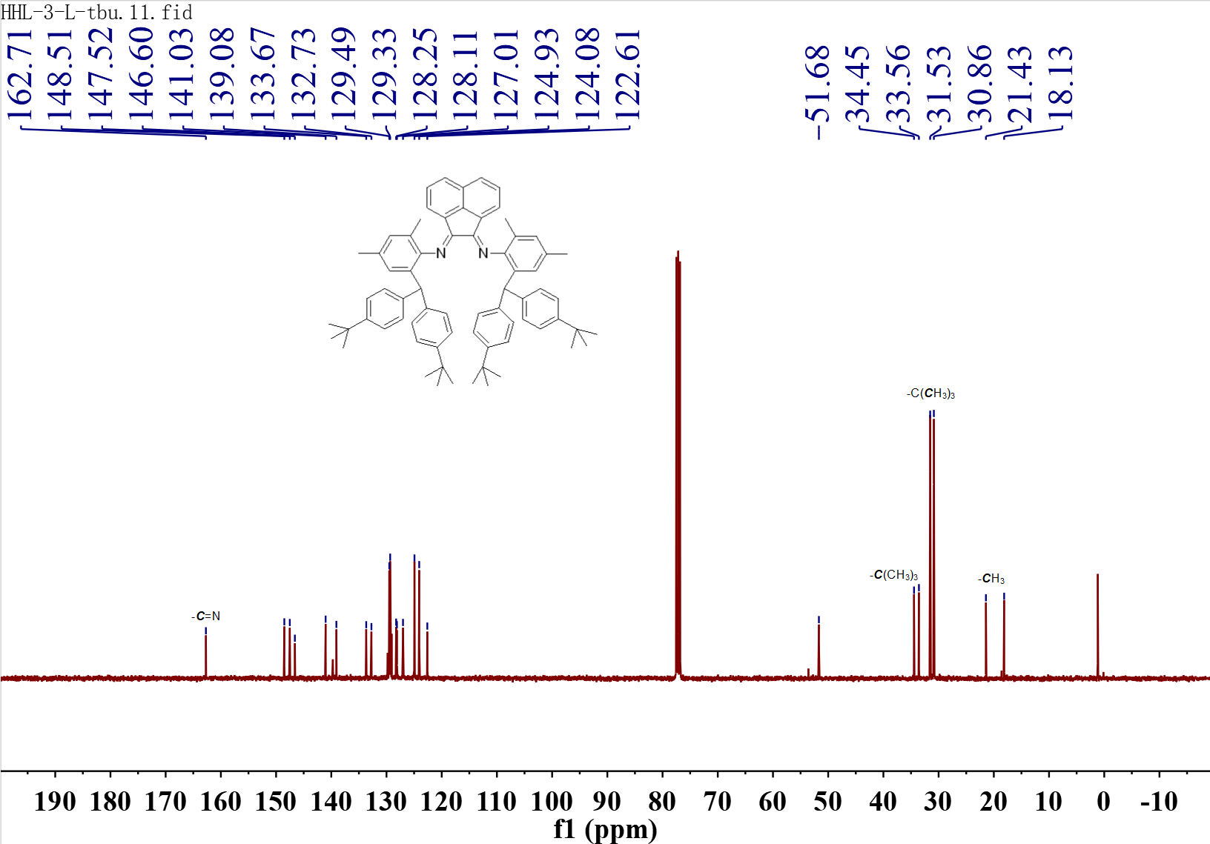

**Figure S9**. 13C NMR (101 MHz) spectrum of **L2** in CDCl3 at 25 °C.



**Figure S10**. 1H NMR (400 MHz) spectrum of **L3** in CDCl3 at 25 °C.

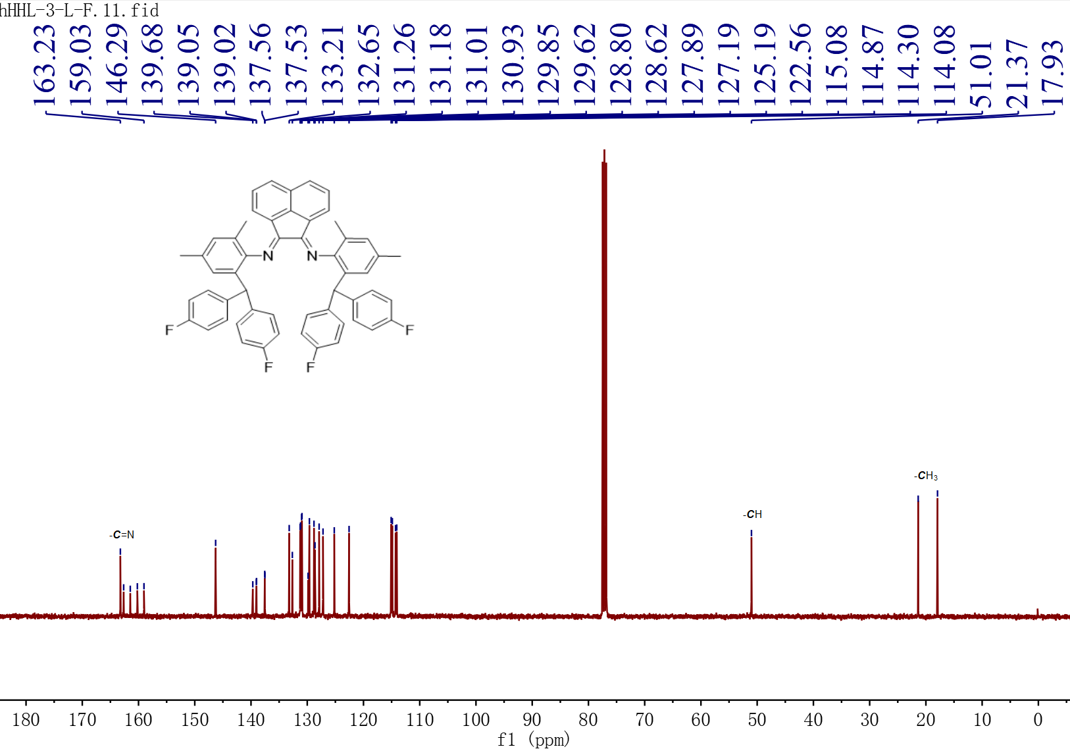

**Figure S11**. 13C NMR (101 MHz) spectrum of **L3** in CDCl3 at 25 °C.

# 4. 1H NMR of the Polymers.



**Figure S12**. 1 H NMR (400 MHz) spectrum of the polymer from Table 1, entry 1 (C2D2Cl4, 120 °C).



**Figure S13**. 1 H NMR (400 MHz) spectrum of the polymer from Table 1, entry 2 (C2D2Cl4, 120 °C).



**Figure S14**. 1 H NMR (400 MHz) spectrum of the polymer from Table 1, entry 3 (C2D2Cl4, 120 °C).



**Figure S15**. 1 H NMR (400 MHz) spectrum of the polymer from Table 1, entry 4 (C2D2Cl4, 120 °C).



**Figure S16**. 1 H NMR (400 MHz) spectrum of the polymer from Table 1, entry 5 (C2D2Cl4, 120 °C)



**Figure S17**. 1 H NMR (400 MHz) spectrum of the polymer from Table 1, entry 7 (C2D2Cl4, 120°C).



**Figure S18**. 1 H NMR (400 MHz) spectrum of the polymer from Table 1, entry 8 (C2D2Cl4, 120 °C).



**Figure S19**. 1 H NMRR (400 MHz) spectrum of the polymer from Table 1, entry 9 (C2D2Cl4, 120 °C).



COOCH3

**Figure S20**. 1 H NMR (400 MHz) spectrum of the polymer from Table 2, entry 1 (C2D2Cl4, 120 °C).



COOCH3

**Figure S21**. 1 H NMR (400 MHz) spectrum of the polymer from Table 2, entry 2 (C2D2Cl4, 120 °C).



COOCH3

**Figure S22**. 1 H NMR (400 MHz) spectrum of the polymer from Table 2, entry 3 (C2D2Cl4, 120 °C)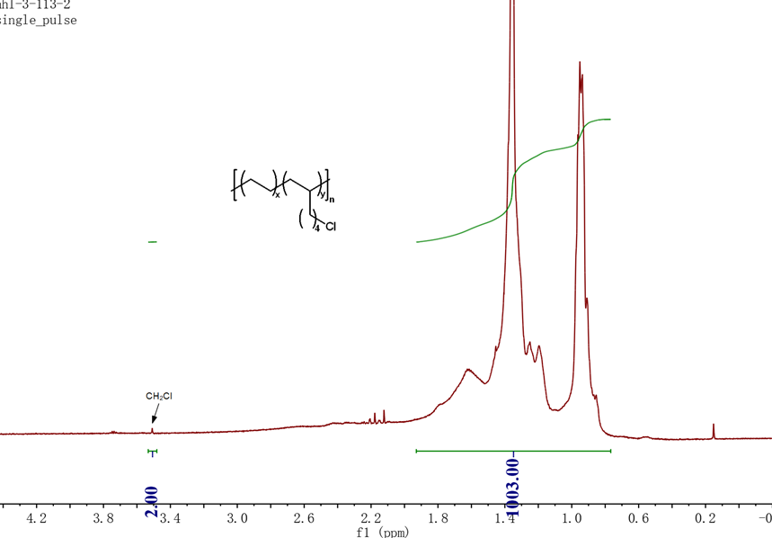

**Figure S23**. 1 H NMR (400 MHz) spectrum of the polymer from Table 2, entry 4 (C2D2Cl4, 120°C).

# 5. GPC Spectrum of the Polymers

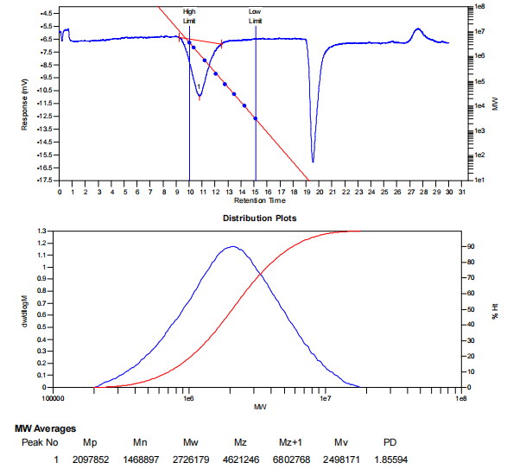

**Figure S24.** GPC of the polymer from Table 1, entry 1.

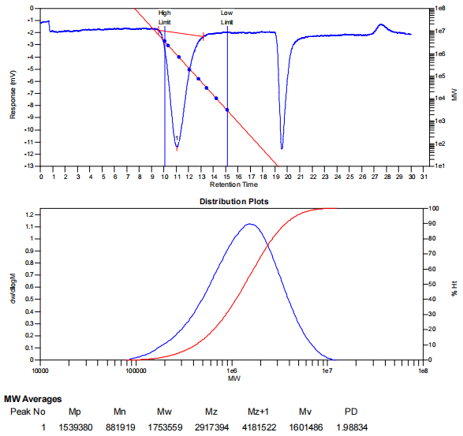

**Figure S25.** GPC of the polymer from Table 1, entry 2.

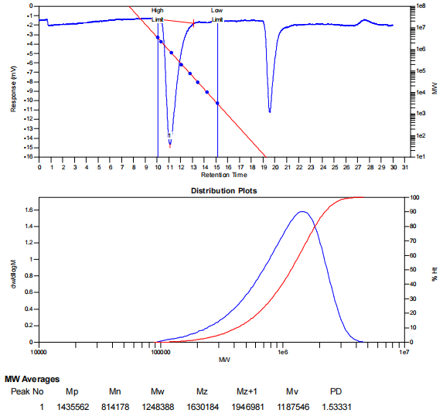

**Figure S26.** GPC of the polymer from Table 1, entry 3.

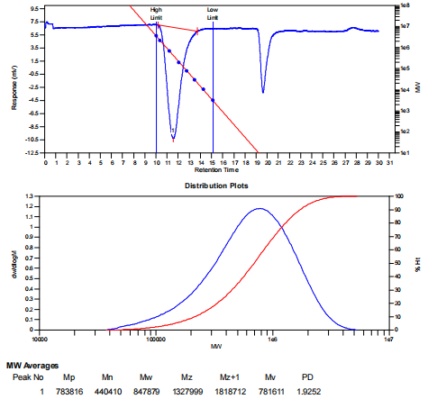

**Figure S27.** GPC of the polymer from Table 1, entry 4.

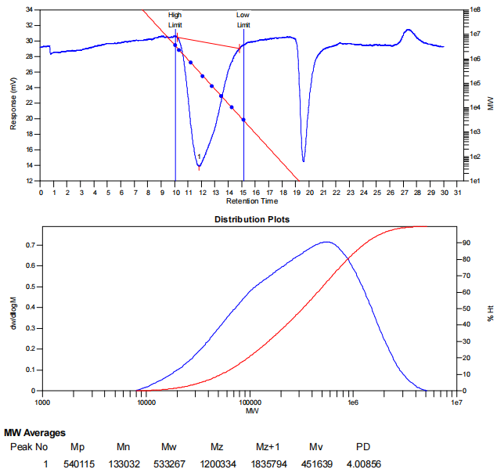

**Figure S28.** GPC of the polymer from Table 1, entry 5.

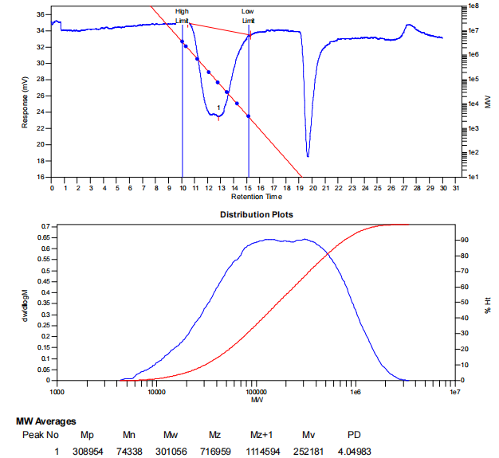

**Figure S29.** GPC of the polymer from Table 1, entry 6.

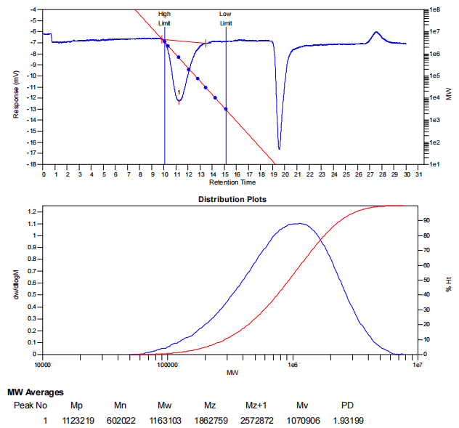

**Figure S30.** GPC of the polymer from Table 1, entry 7.

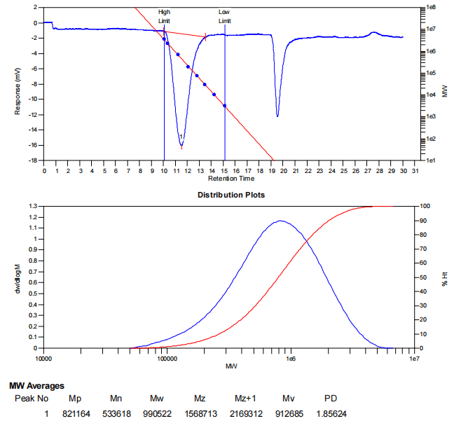

**Figure S31.** GPC of the polymer from Table 1, entry 8.

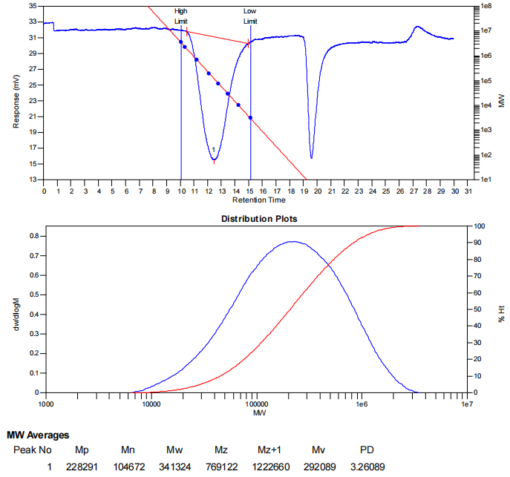

**Figure S32.** GPC of the polymer from Table 1, entry 9.

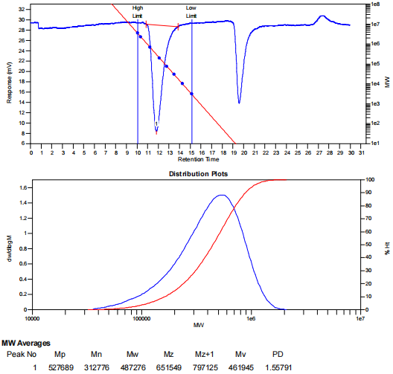

**Figure S33.** GPC of the polymer from Table 2, entry 1.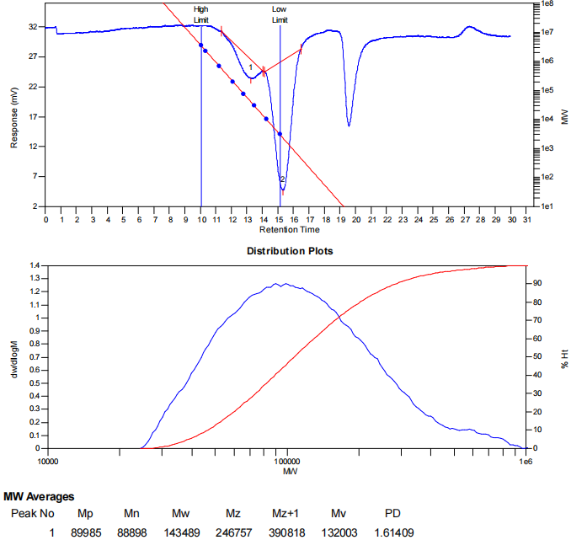

**Figure S34.** GPC of the polymer from Table 2, entry 2.

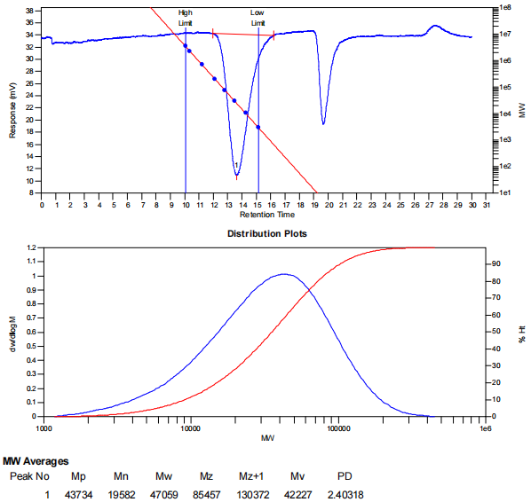

**Figure S35.** GPC of the polymer from Table 2, entry 3.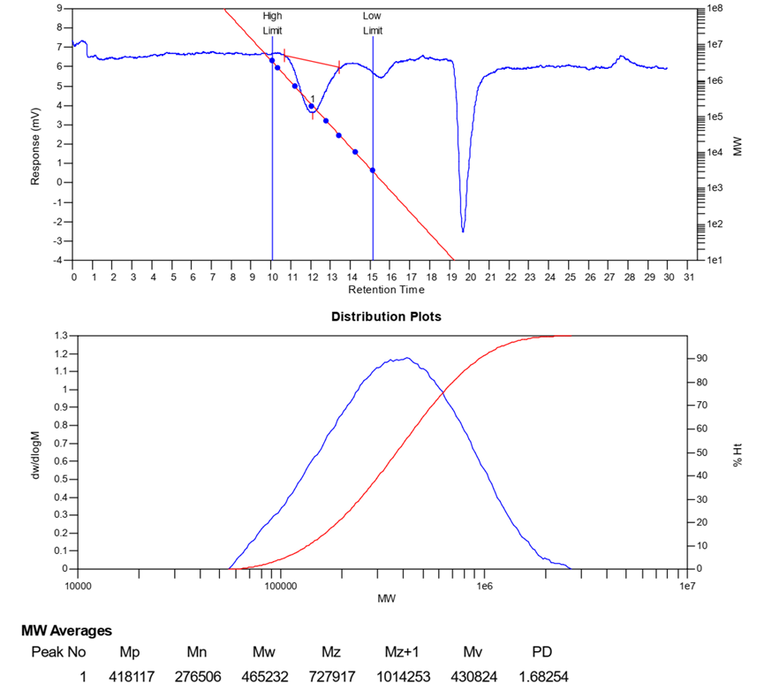

**Figure S36.** GPC of the polymer from Table 1, entry 4.

# 6. DSC of Polymer.

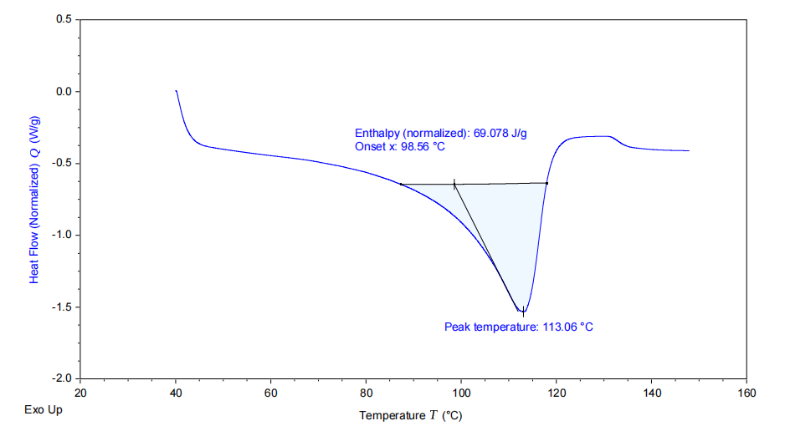

**Figure S37.** DSC of the polymer from Table 1, entry 1.

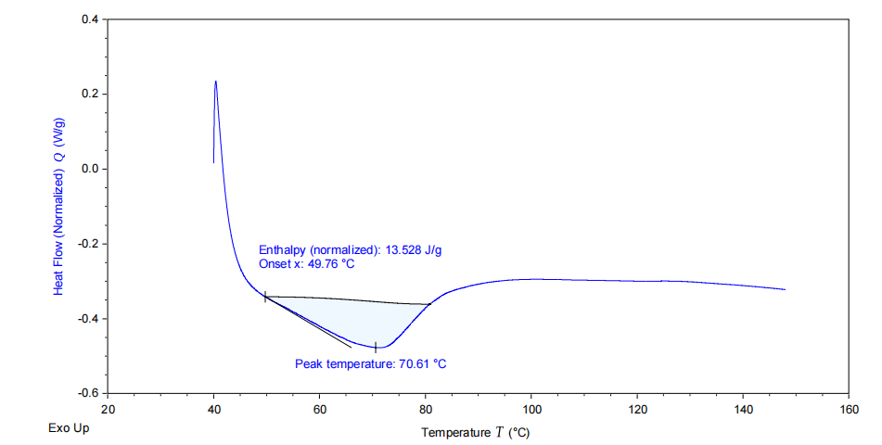

**Figure S38.** DSC of the polymer from Table 1, entry 2.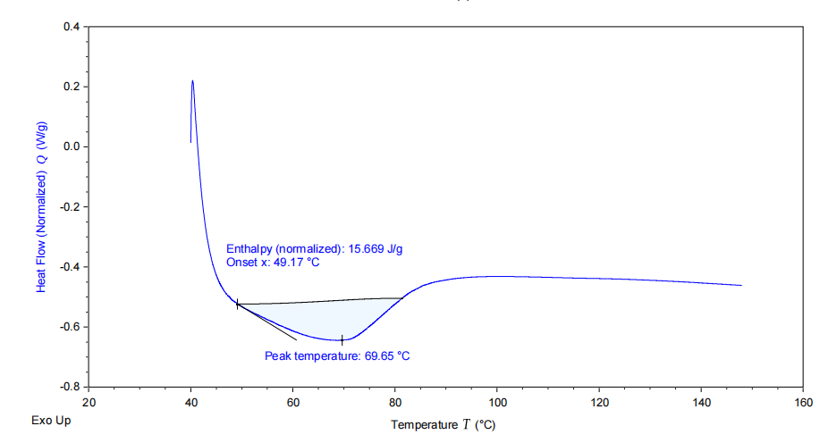

**Figure S39.** DSC of the polymer from Table 1, entry 3.

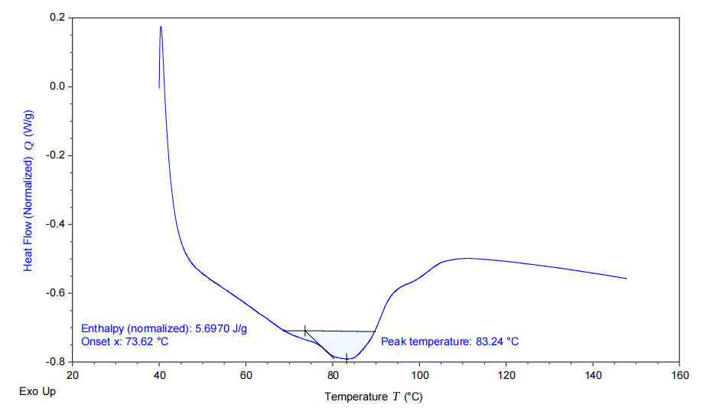

**Figure S40.** DSC of the polymer from Table 1, entry 4.

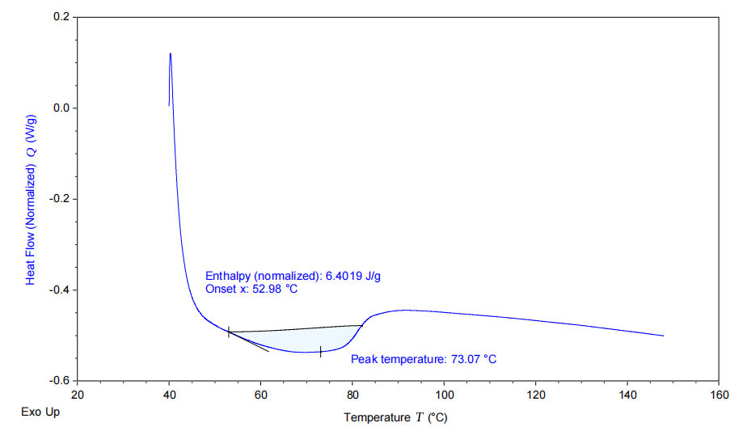**Figure S41**. DSC of the polymer from Table 1, entry 5.

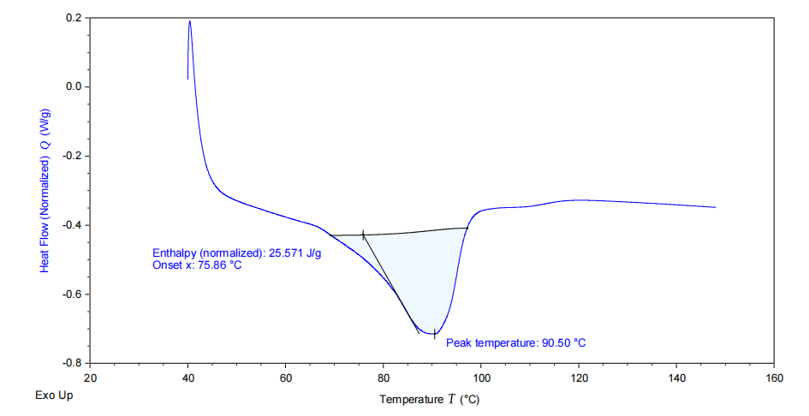**Figure S42**. DSC of the polymer from Table 1, entry 7.

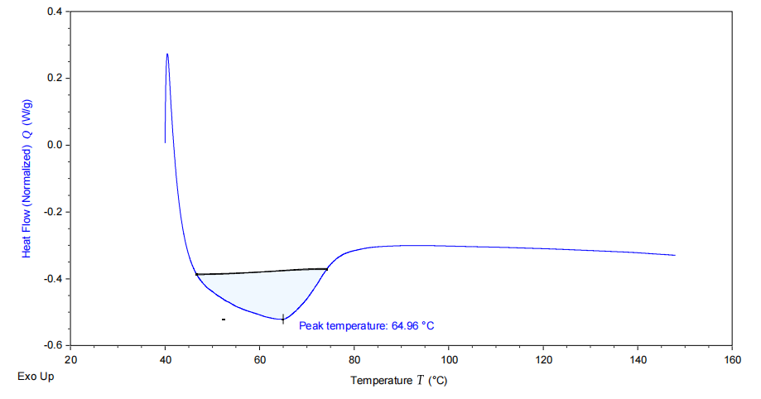

**Figure S43**. DSC of the polymer from Table 1, entry 8.

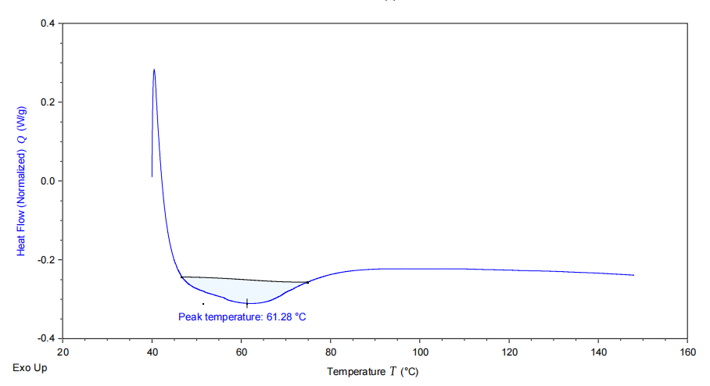

**Figure S44.** DSC of the polymer from Table 1, entry 9.

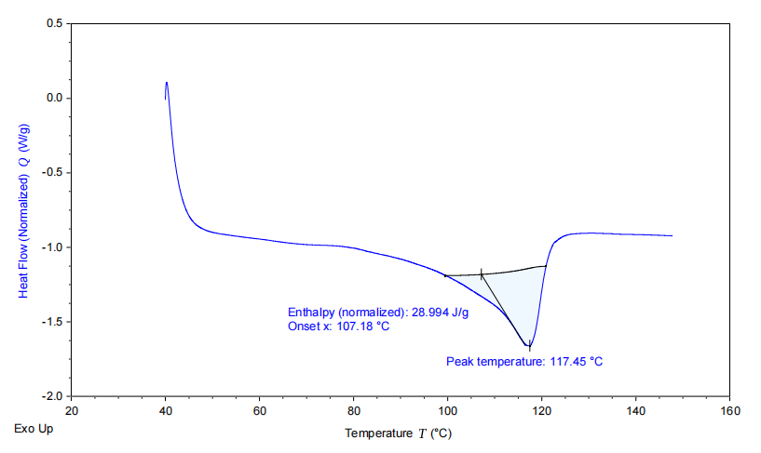

**Figure S45.** DSC of the polymer from Table 2, entry 1.

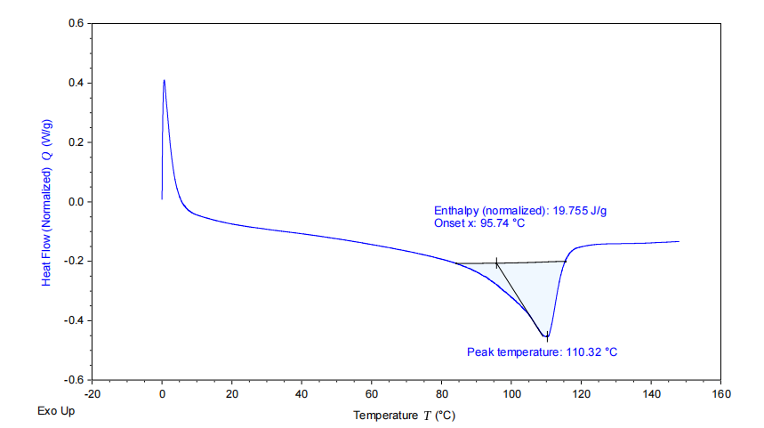

**Figure S46.** DSC of the polymer from Table 2, entry 2.

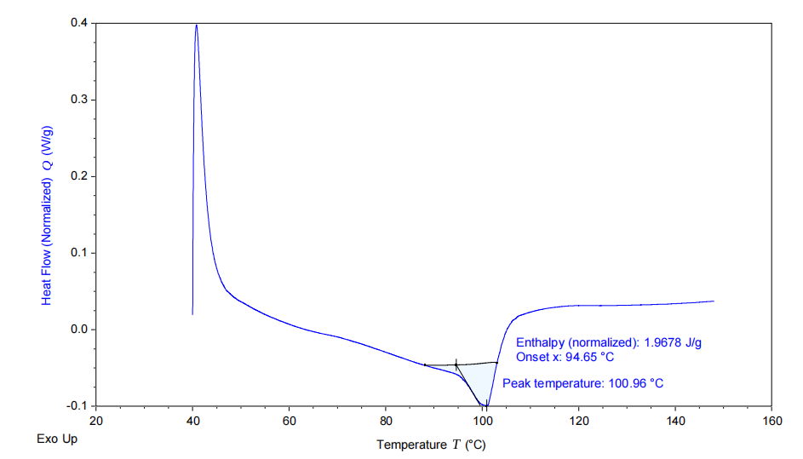

**Figure S47.** DSC of the polymer from Table 2, entry 3. 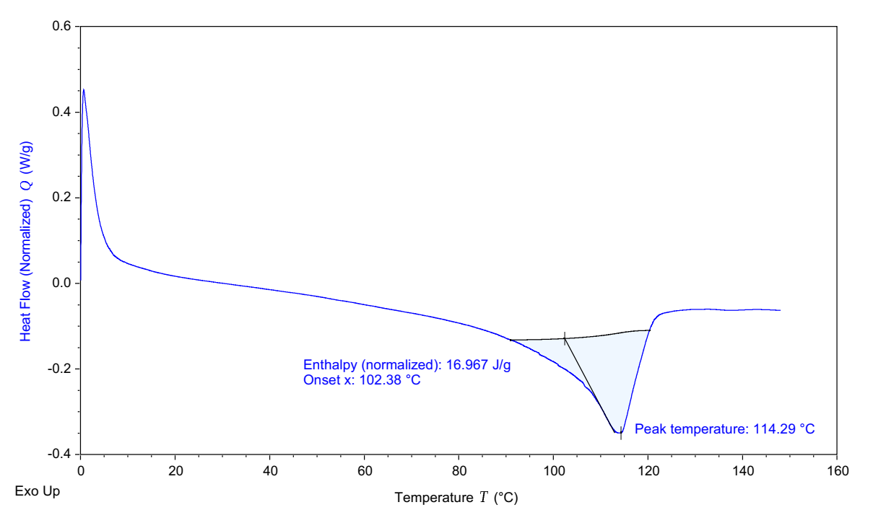

**Figure S48.** DSC of the polymer from Table 2, entry 4.

# 7. X-ray Crystallography

**Table S1**. Crystal data and structure refinement for **Ni2-****Ni3.**

|  |  |  |
| --- | --- | --- |
| Entry | **Ni2** | **Ni3** |
| Formula | C72H80Br2Cl4N2Ni | C54H40Br2F4N2Ni |
| Formula weight | 1333.71 | 1011.41 |
| Temperature [K] | 100 | 100 |
| λ(Mo-Kα) [Å] | 0.71073 | 0.71073 |
| Crystal system | Monoclinic | trigonal |
| Space group | C2/c | P-3 |
| a [Å] | 33.9033(10) | 22.7342(6) |
| b [Å] | 11.5982(4) | 22.7342(6) |
| c [Å] | 18.0723(4) | 16.5296(8) |
| ɑ [°] | 90.00 | 90.00 |
| β [°] | 92.7810(10) | 90.00 |
| γ [°] | 90.00 | 120.00 |
| Volume[Å3] | 7098.0(4) | 7398.6(5) |
| Z | 4 | 6 |
| D(calc) [g·cm-3] | 1.248 | 1.362 |
| µ [mm-1] | 1.589 | 2.065 |
| F (000) | 2768.0 | 3072.0 |
| θ min-max (º) | 4.314 to 52.8 | 4.348 to 52.796 |
| h | -42→ 38 | -23→ 28 |
| k | -14→ 12 | -28→ 28 |
| l | -22→20 | -15→ 20 |
| Reflections collected | 24099 | 48886 |
| Reflections unique | 7146 | 10107 |
| R(int) | 0.0601 | 0.0991 |
| Data / restraints / parameters | 7146/464/405 | 10107/0/572 |
| Final R indices [I>2σ(I)] | R1 = 0.0444  wR2 = 0.1183 | R1 = 0.0398  wR2 = 0.0871 |
| R indices (all data) | R1 = 0.0600  wR2 = 0.1282 | R1 = 0.0622  wR2 = 0.0958 |
| GOF on F2 | 1.035 | 1.027 |

# 8. References

(1) Fisher, K. M.; Bolshan, Y. J. Org. Chem. 2015, 80, 12676.

(2) Wieteck, M.; Tokimizu, Y.; Rudolph, M.; Rominger, F.; Ohno, H.; Fujii, N.; Hashmi, A. S. K. *Chemistry-A European Journal* **2014** , *20*, 16331.

(3) Landwehr, A.; Dudle, B.; Fox, T.; Blacque, O.; Berke, H. *Chem. Eur. J.* **2012**, *18*, 5701.

(4) Li, A.; Ma, H.; Huang, J. *Appl. Organomet. Chem.* 2013, 27, 341-347.